The Garvey School/Egun Omode Shule

102 Taylor St., Trenton, NJ (609) 792-9038

Email: thegarveyschool@aol.com

Bakari Summer Enrichment Program
Registration Form
$25 REGISTRATION FEE (NON-REFUNDABLE)

PLEASE FILL OUT THE FORM BELOW

Child’s Name ______________________________ Grade ____

Date of Birth _________ School _______________________

Gender: M F

Child’s Name ______________________________ Grade ____

Date of Birth _________ School _______________________

Gender: M F

Address ___________________________________________

City _______________________ State _____ Zip __________

Mother’s Name ______________________________________

Mother’s Phone __________________ cell _______________

Work ________________________

Father’s Name ______________________________________

Father’s Phone ___________________ cell _______________

Work _______________

Emergency contact ___________________________________

Relationship to child _________________________________

Phone __________________ cell _______________________

Names of other adults allowed to pick up child

__________________________________

__________________________________

__________________________________

ACTIVITIES/INTERESTS/HOBBIES
Please list any activities, interests and hobbies your child(ren) are involved in ___________________________

________________________________________________

________________________________________________

________________________________________________

PHOTO RELEASE

I hereby give my permission for my child/children to be photographed and/or videotaped during the Bakari Summer Enrichment Program. Bakari has permission to use my child(ren)’s name and/or picture for any publicity purposes, including but not limited to, newspaper, newsletter, website, social media, etc. involving this summer or future Bakari activities.

____________________________ ____________
Signature Date

List any allergies, medical conditions, and/or food restrictions:

__________________________________________________________________________________________________
__________________________________________

MEDICAL RELEASE

In the event of an emergency or illness, I give permission to the staff, or a designate of the Bakari Summer Enrichment Program, to handle any necessary medical treatment that my child(ren) may need while participating in an activity of the camp. I understand that I will be notified in the case of a medical emergency involving my child. In the event that I cannot be reached, I give permission for the calling of medical assistance or providing necessary medical care, (including treatment at the nearest hospital, if needed) in the event my child becomes injured or is ill. Further, I understand that Bakari and those working with the campers will not be responsible for the medical expenses incurred, but that such expenses will be my responsibility as a parent/guardian.

____________________________ ____________
Signature Date
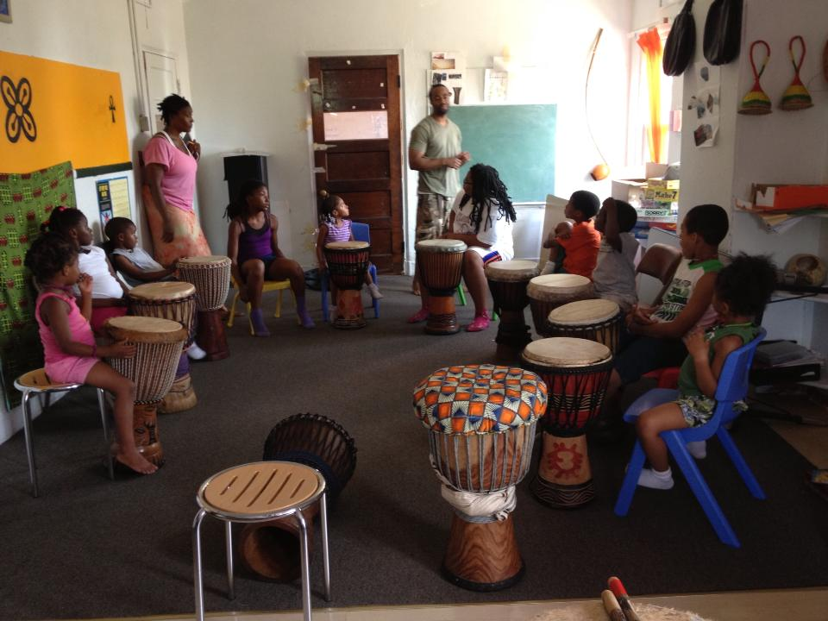

BAKARI SUMMER ENRICHMENT PROGRAM

DATES: June 22-July 31

TIMES: 8:00 am-4:30 pm

PAYMENTS ARE AS FOLLOWED:

- $30 registration fee

- $280 due June 19, 2014

- $280 due July 3, 2014

- $280 due July 17, 2014

**20% discount for any additional children

Failure to pay tuition in a timely manner will result in your child’s termination from camp (with no refunds).

LUNCH and SNACKS are provided by the parents.

BAKARI
RULES AND RESPONSIBILITIES

- Parents agree to pay tuition according to the schedule provided, the same amount, regardless of whether your child misses any days. Payments are made two weeks prior to service. Provisions may be made to non-voucher parents if BAKARI closes for an emergency.

- Parents agree to drop off child no earlier than 8 am and pick-up child no later than 4:30 pm. Any child(ren) picked up after 4:30 pm may be subject to a $5 late fee. Repeated offenses may result in you being charged the $10 daily late fee. Extreme situations may result in the child(ren) being dismissed from Bakari. In the event the child will be excessively late or absent, parents agree to contact the shule (school) to inform us. Aftercare (until 5:00 pm) is available, please inquire.

- Lunch is be provided by the parents. No four-legged animal is permitted: Pork, beef, goat, lamb, etc. We encourage brown bag lunches (sandwiches, leftovers, etc.) that can be eaten, enjoyed and easily disposed. Do not send in a heat-up on trip days (Wednesdays). Lunchables are prohibited.

- We encourage the highest nutritional diet for our children. We do not allow any C & C, hugs, or any other kind of drinks. Only 100% JUICE is permitted. Also, no candy, sugary cakes such as cinnamon buns, donuts, etc. are permitted. Snacks should consist of fruit, bars, crackers, cookies, chips, etc.

- Provide your child(ren) with a water bottle filled with ice cold water. Children need PLENTY of water everyday throughout the summer.

- Super heroes and such as Batman, Superman, Iron Man, Cinderella, Spongebob, Spiderman, Bratz, and other images that do not reflect the cultural values of Black people are NOT permitted in the shule. Animals and characters that are permitted include, but are not limited to, Dora, Princess Tiana, Elmo, Yo Gabba Gabba, etc. Why these characters in particular? These are characters that neither celebrates the culture of Black/Latino people, show Black/Latino people in a positive manner, while promoting the glamorization of humor, beauty and supernatural powers of heroes/sheroes that do not look like US.

- Children must wear appropriate comfortable clothing and footwear (ideally sneakers). In the event the child wears open-toed shoes, sandals, flip-flops, etc., send in a pair of sneakers.

- Participants must fully participate in all activities.

- Parents may not use profanity or rude/obscene gestures towards adults, their children and/or other children within or outside the institution. It is a given that children are not permitted to use profanity.

- Children will show respect to all adults and follow all rules set-forth.

- Persistent and habitual fighting, biting, non-compliance, or gross disrespect of adults and towards other children may be cause for immediate dismissal from BAKARI.

- All rules, responsibilities and commitments are to be followed at all times.

I have read and understand the rules and regulations. I further understand that any participant that does not follow these rules will be warned; a second violation will result in a call home; and if the behavior persists, the child will be dismissed from the program.

Parent/Guardian Signature: _____________________________

Parent/Guardian Print: __________________________________

Parent/Guardian Signature: _____________________________

Parent/Guardian Print: __________________________________

Date: ___________________

